Tableau superstore dataset is considered for this assessment. It is the widely used dataset. It is accessible within Tableau Desktop installations and it is available in tableau online resources. The link for the dataset <https://public.tableau.com/app/learn/sample-data>. The dataset consists three tabs such as Orders, Returns and People. The table “Orders” has variables such as Row ID, Order ID, Order Date, Ship Date, Ship Mode, Customer ID, Customer Name, Segment, Country, City, State, Postal Code, Region, Product ID, Category, sub-category, Product Name, sales, Quantity, Discount and profit. The table “Returned” contains variables such as Returned and OrderID. The table “people” contains variables such as person and region.

In Orders table, Row ID is the unique identifier for each row. Order id represents the unique identifier for each order. Order date indicates the date an order was placed. It is useful for time – series analysis. Ship date represents the date on which order was shipped. ship mode indicates the mode of shipment such as first class, same day, second class or standard class. Customer ID is the unique identifier for each customer. Customer name is the name associated with each customer. Segment represents the categorization of customers into consumer, corporate or home office. Country indicates the country from where the order was placed. City contains the city of US. In addition to these, table also contains state, postal code and region to represent location information. Product ID is the unique identifier of each product. Category is the grouping of products into different categories including furniture, office supplies and technology. Sub-category contains the further division of each category. Product name represents the name of each product. Sales conveys the total revenue generated by each order. Quantity is the number of units sold in each order. Discount is the discount given to that specific order. Profit conveys the profit earned from each transaction (Abhishek Duggal 2024).

The table “Returns” contains two variables such as returned and order ID. Returned is the binary variable that contains values either “yes” or “No”. Order ID is the order ID in the Order table.

The table “people” contains variables such as person and region. Person represents the name of the individual responsible for a specific region. Region corresponds to the region in the orders table.

By analysing Superstore dataset, it is possible to explore various questions for providing actionable insights. Following are the key questions:

Product profitability & performance

* Which product categories or sub categories generate the highest profit?
* Which manufacturers contribute the most to profitability?
* How to discount rates impact sales and profit margins by product line?

Customer demographics and segmentation

* Which customer segments are the most valuable?
* What are the purchasing patterns across customer demographics?
* Are there any customer segments with high return rates?

Geographic sales & profit trends

* Which state or regions have the highest and lowest sales and profit margins?

Shipping & operational efficiency

* How do different shipping modes impact profit and delivery times?
* Which products or categories consume more delivery times?

Discount and sales impact analysis

* What is the effect of various discount levels on overall sales & profitability?
* Which product lines benefit most from discounts?

Time based trends

* How do sales and profit trends vary month to month or quarter to quarter?

**Problem statement**

The management of Superstore needs actionable insights into product profitability, customer behaviour, discount impact, regional performance and operational efficiency for optimizing business strategies, enhancing customer satisfaction, maximizing profit etc. These insights enables Superstore to make data driven decisions.

**Profit by category and sub category**

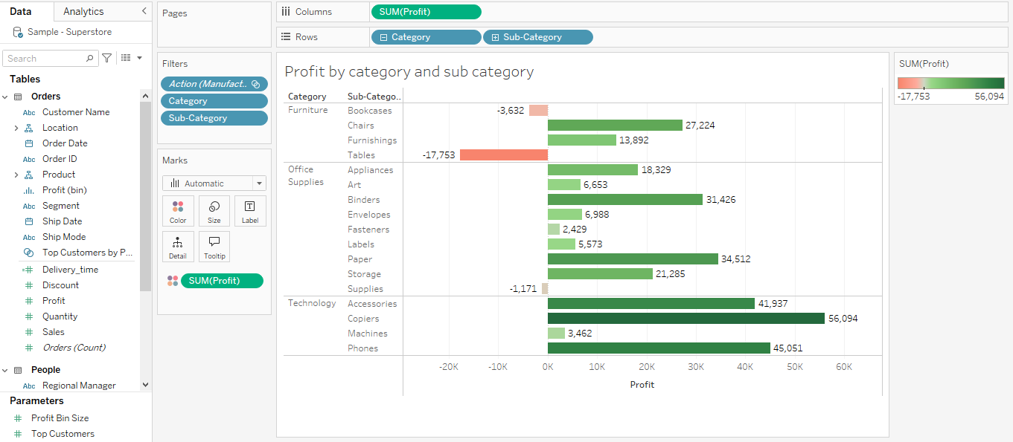

This dashboard contains bar chart. It involves variables such as profit, category and sub category. To apply colors based on profit, profit will be dragged and dropped on colors in the “Marks” section. The main target audience for this dashboard are senior management and product managers. The secondary target audiences are marketing teams. This dashboard provides insights on profitable product categories and sub categories. It enables the target audience for allocating more resources for high profit product categories.

The chart shows that, there are 3 categories of products such as furniture, office supplies and technology. In Furniture category, Book cases and Tables incur losses whereas Chairs generates high profit.

**Profit by state**

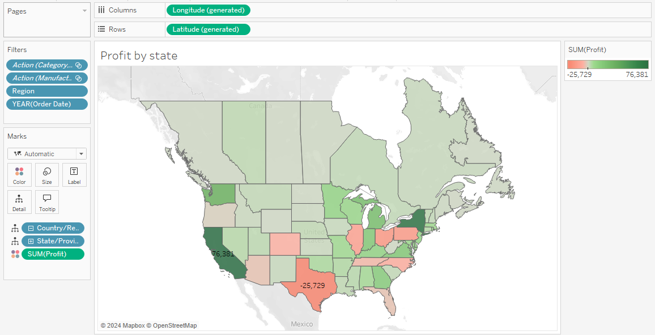

Map is used to display profit by state. By dragging state and profit into the visualisation canvas, Tableau will display the data in the Map. Profit has to be dropped into the “color” option of “Marks” card.

The target audiences for this dashboard are senior management and regional sales managers. This dashboard provides visual representation of profit across different state that enables the business to monitor where the business is most as well as least profitable geographically.

The insights on state with higher profits enable business to implement strategies for maintaining or increasing performance. It also enables the business to figure out the states with low profit that enables to analyse root causes for the low profit (Sujat khan 2023). The state which generates highest profit is California (76,381). The state which gives lowest profit is Texas.

**Profit by manufacturer**

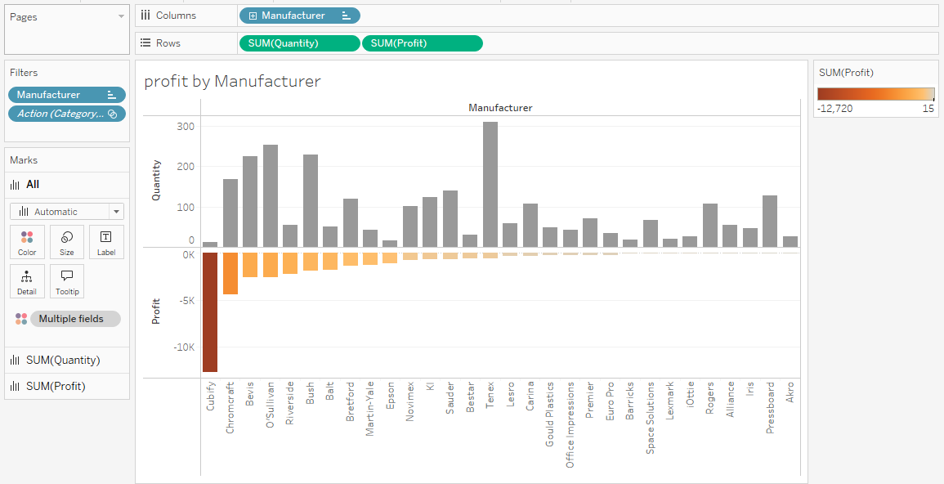

By expanding “product”, it will display

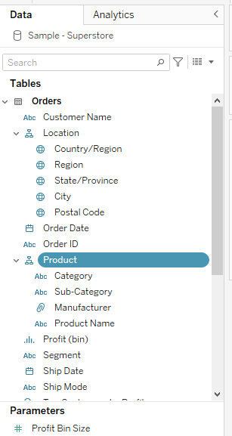

category, sub-category, manufacturer and product name.

Dragging the “manufacturer” into columns and “quantity” into rows. By clicking on “manufacturer” which is in the rows and selecting sort🡪ascending order by field “profit”.

Again, click on “, “manufacturer” and selecting “filters” 🡪 by field🡪 bottom (30) and “Profit” 🡪 apply 🡪 ok

Drag the “profit” column and drop into the color section of Marks card.

Drag the “quantity” also in the rows section. Select “Entire view”. To remove colour for the “Quantity”, click on the “Quantity” chart and remove sum(profit) from colour (Morton et al 2012).

This Dashboard provides the insights about the manufacturer and profit. It shows manufacturers that contribute for least profit. The top 3 manufactures who contribute for the least profits are Cubify, Chromcarft and Belvis.

**Profit analysis**

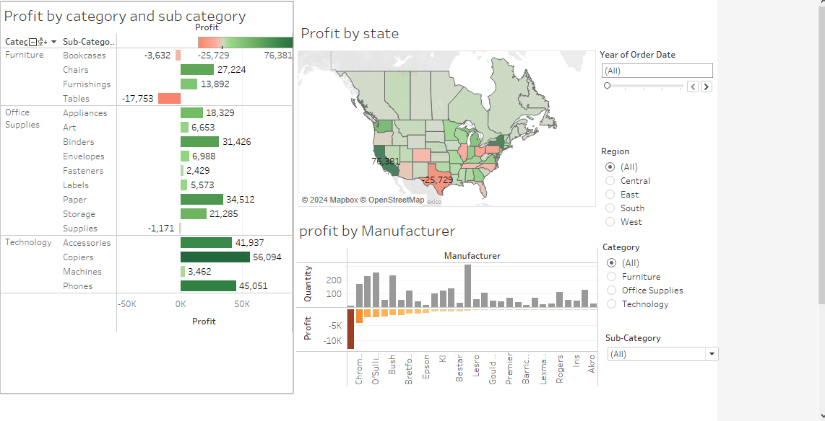

Dashboard is created by clicking on the dashboard tab. In the objects section, floating is selected. In order create the interactive dashboard, against each visualisation, need to click on filter. The complete dashboard provides insights about the profit by category and subcategory, state as well as manufacturer.

In the dashboard, click on filters against “profit by category and sub category” and seletc -- category and sub category.

**Sales and profit by state**

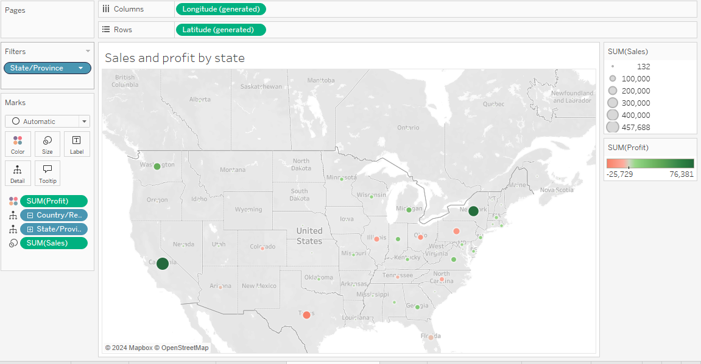

The map illustrates the sales and profit by state. By expanding, location that will display country, Region, state, city and postal code. Drag and drop the field “State” into the visualisation canvas, state will be displayed in the map. Next, drag the profit and paste over the map. According to the profit, size of the circle is changing. In addition to profit, sales is also dragged and dropped over the map. Color is applied for profit.

California is the state which contributes for high profit. Sales in California is 457,688. Sales and Profit in the state “New York” are 74, 039 and 310, 876.

**Sales and Profit trend**

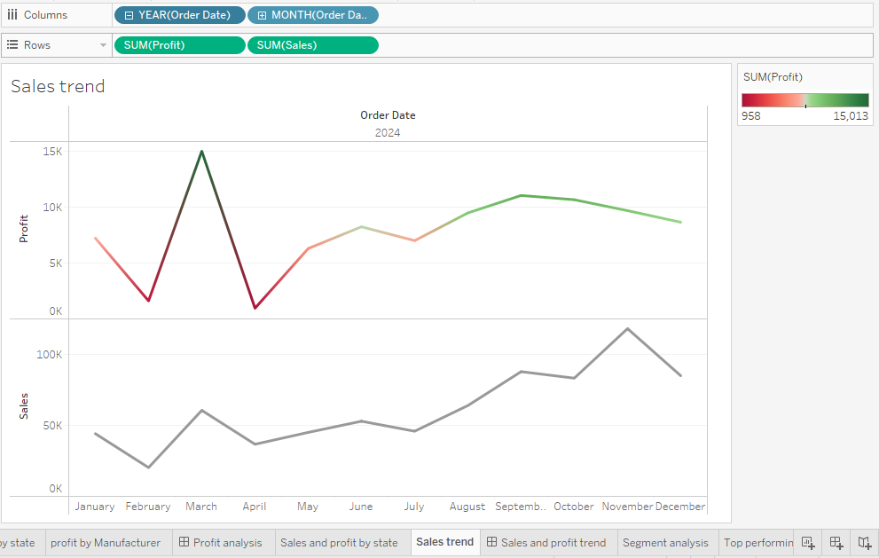

Sales and profit trend is illustrated using the line chart. Order date is dragged into the columns and profit as well as sales are also dragged into columns. Line chart is used to illustrate the line trends.

The chart illustrates the sales and Profit trend for the year 2024. Profit is start decreasing from the Month September to December.

**Sales and profit trend – dashboard**

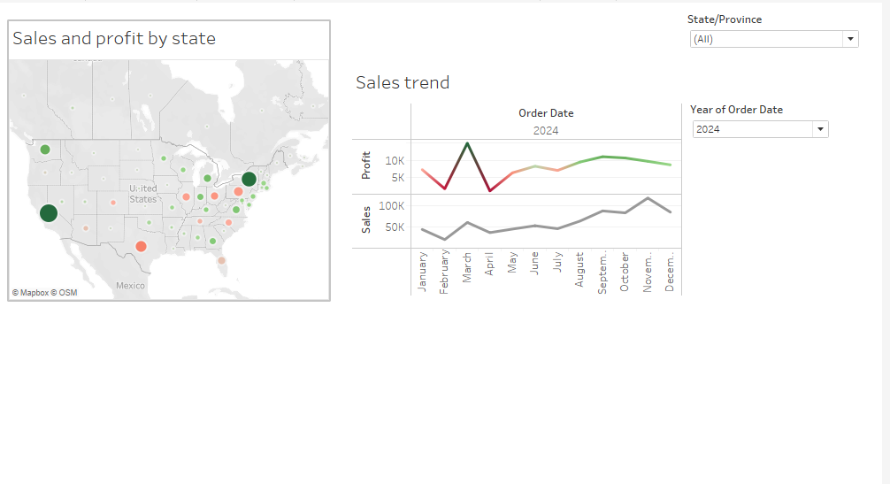

The above dashboard illustrates the sales and profit by state and also on specific year.

**Customer segment analysis**

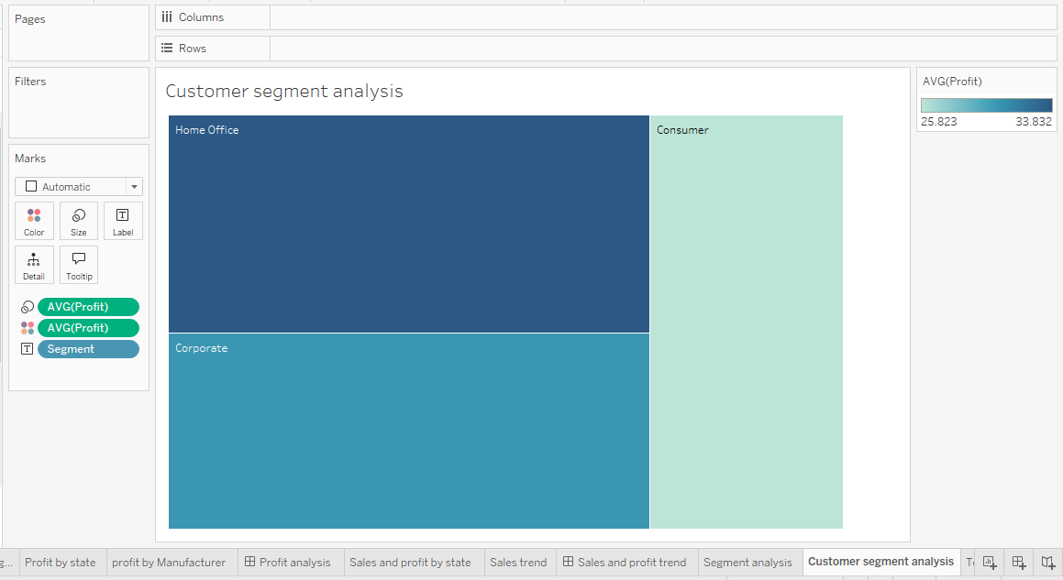

The above pie chart illustrates the customer segments of super store. It illustrates that, “Home Office” segment gives highest average profit. The intensity of colors in the heat map is used to highlight how the average profit varies among the segments. Home office is the more profitable segment.

**Top performing consumers**

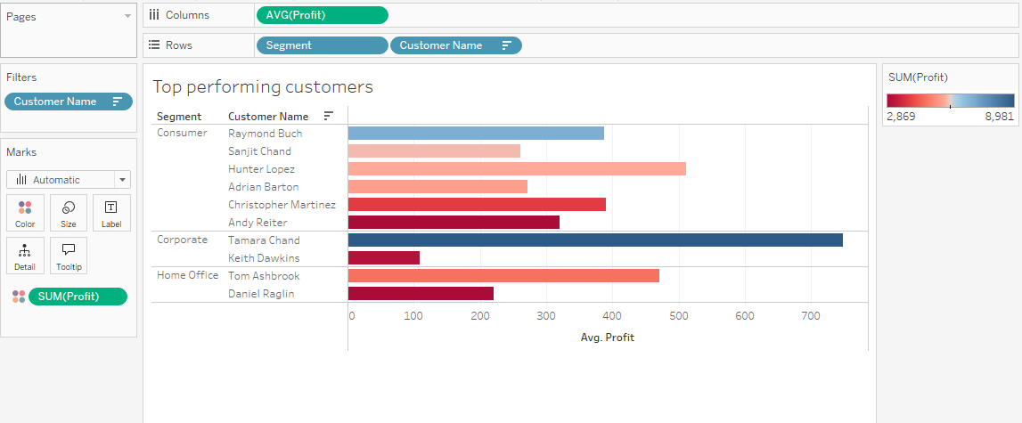

The above bar chart illustrates the top performing consumers from each segment and based on average profit. From consumer segment, top performing customers Raymond Buch, from Corporate (Tamara Chand) and from Home office Tom Ashbrook. This analysis helps marketing team to maintain relationship with top performing customers by offering loyalty rewards and exclusive discounts.

**Customer analysis**

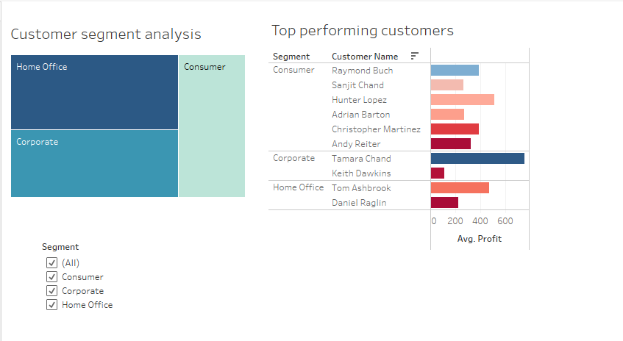

The above dashboard illustrates, customer analysis. It illustrates the customer segments who contribute for high average profit and top performing consumers.

**Discount and Profit**

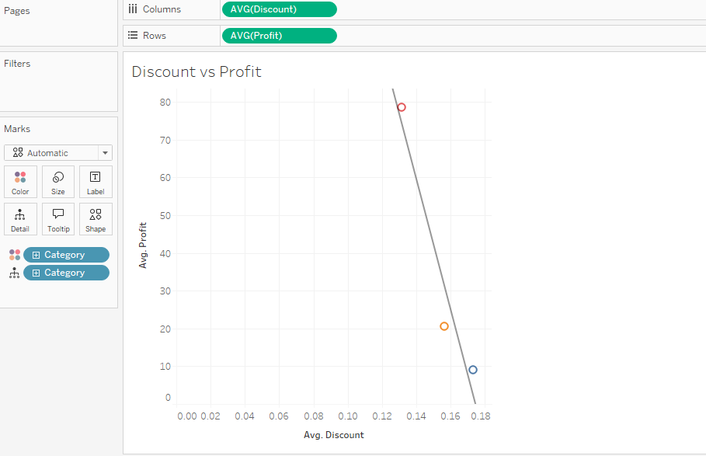

The scatter plot and trend line illustrates the relationship between average discount and average profit. For product category “Technology” average discount is low whereas average profit is high. Among all product categories, highest average discount is for the category “Furniture” but it gives lowest average profit.

**Relationship between discount, sales and profit**

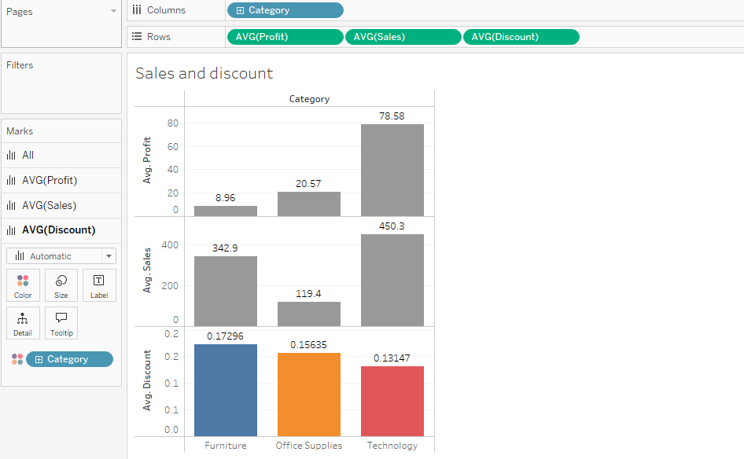

The above visualisation illustrates the relationship between, discount, profit and sales. In this dashboard, category “Furniture” receives highest discount and but gives low profit. Technology gets lowest discount but gives highest average profit.

**Shipping mode Vs Profitability**

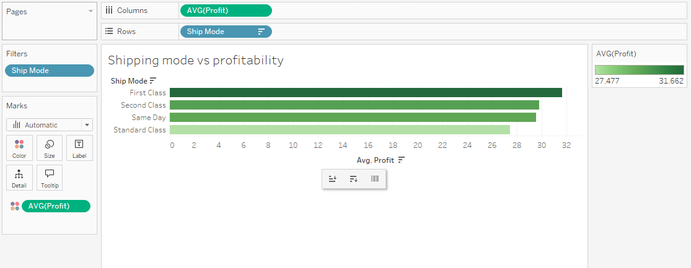

Average profit is higher for the ship mode “First class”. It illustrates that, there is strong relationship between shipping modes and profitability. Customers who select “First class” shipping may frequently purchase high- value or high margin products that results into higher profits.

**Delivery time Vs shipping mode**

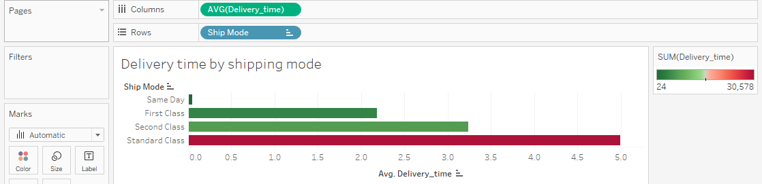

Average time is higher for the shipping mode “Standard class”. Average delivery time is very low for the shipping mode “Same day”. The above analysis illustrates that, standard class customers who are cost sensitive and willing to wait for their orders. Same day means consumers are in urgent needs. These type of mode is often chosen by high value customers.

**Operational efficiency analysis**

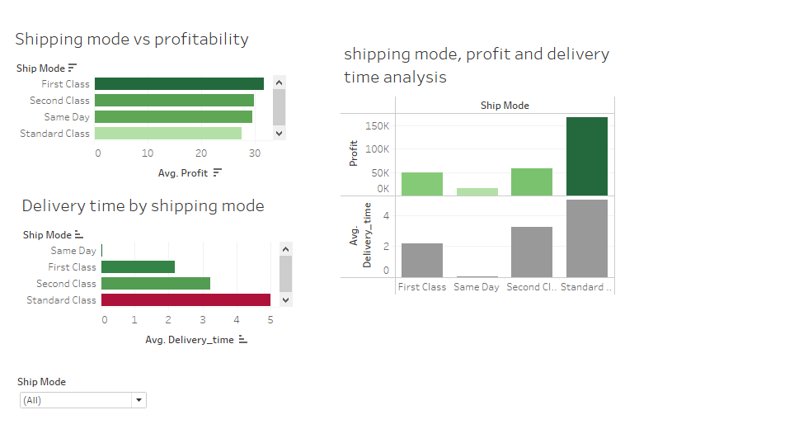

**Product category, sub-category, profit and order date**

By analysing these variables, it is possible to understand which product categories or sub-categories yields high profit. It is possible to make decision about product inventories and marketing promotions. It is possible to identify seasonal or trend based on profit fluctuations based on specific categories.

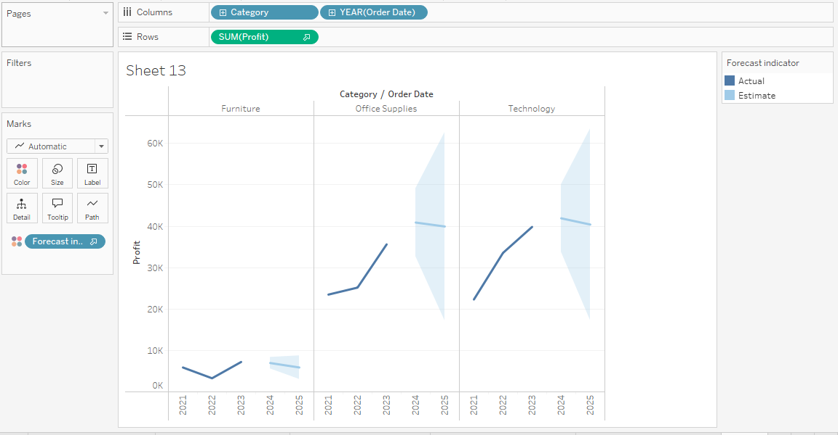

Here, projections are made for 5 quarters from 2024 Q$ to 2025 Q4. Forecasting are done using the data from 2021 Q1 to 2024 Q3. According to this forecast, profit is expected to increase by $1,301 from initial value by 2025 Q4. Profit is expected to remain the same with no increase or decrease by 2025 Q4. Profit is expected to remain the same with no increase or decrease by 2025 Q4 (Battle et al 2019).

Furniture shows a positive growth trend which shows further investment can be done on this. Office supplies and technology show stability which means these categories do not show significant growth (Data et al 2016).

**Customer segment analysis**

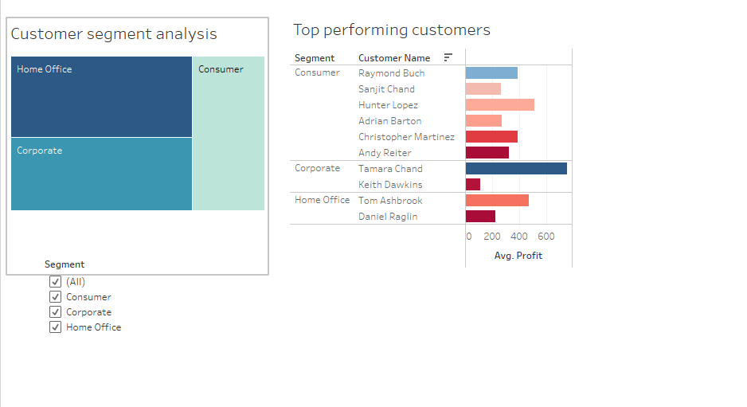

Home office segment generates highest average profit. There are various reasons for the highest average profit such as customers may purchase high – margin products or place frequent bulk orders etc. Consumer segment yield lowest average profit among the three groups. Consumers mostly focuses on low –cost products that results into reduced profit (Orj et al 2022).

**Sales by discount impact**

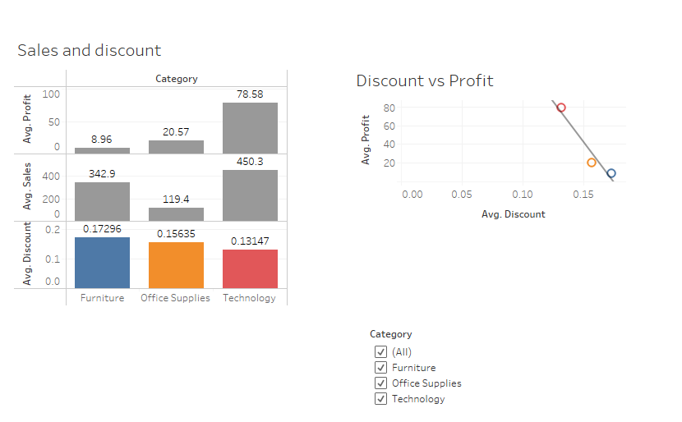

This analysis evaluates how discounts influence both sales volume and profit margins across categories. This analysis shows that, high discounts is given for furniture that results into low profit. Discount is low for technology but that results into average high profit.

**Operational performance**

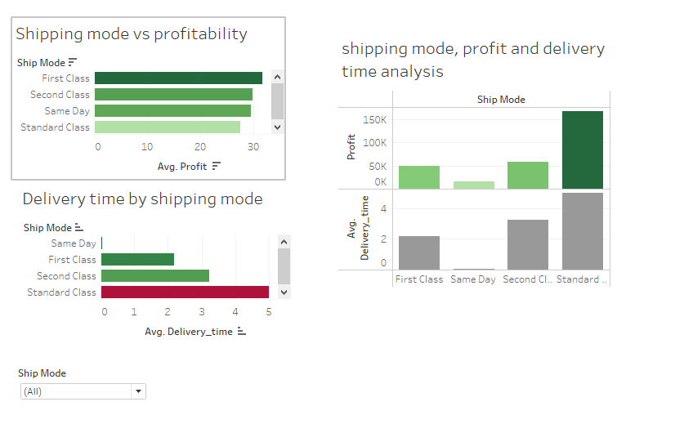

High profitability for the shipping mode “First class”. Delivery time is high for standard class.

## References

Data, M. C., Komorowski, M., Marshall, D. C., Salciccioli, J. D., & Crutain, Y. (2016). Exploratory data analysis. *Secondary analysis of electronic health records*, 185-203. <https://link.springer.com/content/pdf/10.1007/978-3-319-43742-2_15.pdf>

Battle, L., & Heer, J. (2019, June). Characterizing exploratory visual analysis: A literature review and evaluation of analytic provenance in tableau. In *Computer graphics forum* (Vol. 38, No. 3, pp. 145-159). <http://idl.cs.washington.edu/files/2019-CharacterizingEVA-EuroVis.pdf>

Orji, U., Ugwuishiwu, C., Okoronkwo, M., Asogwa, C., & Ogbene, N. (2022). Visual Exploratory Data Analysis of the Covid-19 Vaccination Progress in Nigeria. *arXiv preprint arXiv:2208.09650*. <https://arxiv.org/pdf/2208.09650>

Abhishek Duggal (2024). Understanding Tableau Superstore Dataset: 4 Important Points. <https://hevodata.com/learn/tableau-superstore-data/>

Sujat khan (2023). SuperStore Tableau Analysis. <https://medium.com/@sujatkhan24/superstore-tableau-analysis-4a75e111cf42>

Morton, K., Bunker, R., Mackinlay, J., Morton, R., & Stolte, C. (2012, May). Dynamic workload driven data integration in tableau. In *Proceedings of the 2012 ACM SIGMOD international conference on management of data* (pp. 807-816). <https://freakalytics.com/wp-content/uploads/modi221-mortonA.pdf>